**DAILY ONLINE ACTIVITIES SUMMARY**

|  |  |  |  |  |  |  |  |  |
| --- | --- | --- | --- | --- | --- | --- | --- | --- |
| **Date:** | **13-6-2020** | | | | | **Name:** | **Poojashree T** | |
| **Sem & Sec** | **8th sem B sec** | | | | | **USN:** | **4al16cs064** | |
| **Online Test Summary** | | | | | | | | |
| **Subject** | | **Internet of Things** | | | | | | |
| **Max. Marks** | | **30** | | **Score** | | | **29** | |
| **Certification Course Summary** | | | | | | | | |
| **Course** | **Introduction to R language tutorial** | | | | | | | |
| **Certificate Provider** | | | **Great learning academy** | | **Duration** | | | **3.0hr** |
| **Coding Challenges** | | | | | | | | |
| **Problem Statement:** **1**. **to read the number and compute the series.**  **2. to count the number in th series.**  **3. to check whether number is palindrome or not.**  **4. to find the number between 0 and 50 which are not divisible by 2 and 3.**  **5.micro and array update**  Top of Form | | | | | | | | |
| **Status:completed** | | | | | | | | |
| **Uploaded the report in Github** | | | | | **yes** | | | |
| **If yes Repository name** | | | | | **Poojatgowda** | | | |
| **Uploaded the report in slack** | | | | | **yes** | | | |

**Online test**

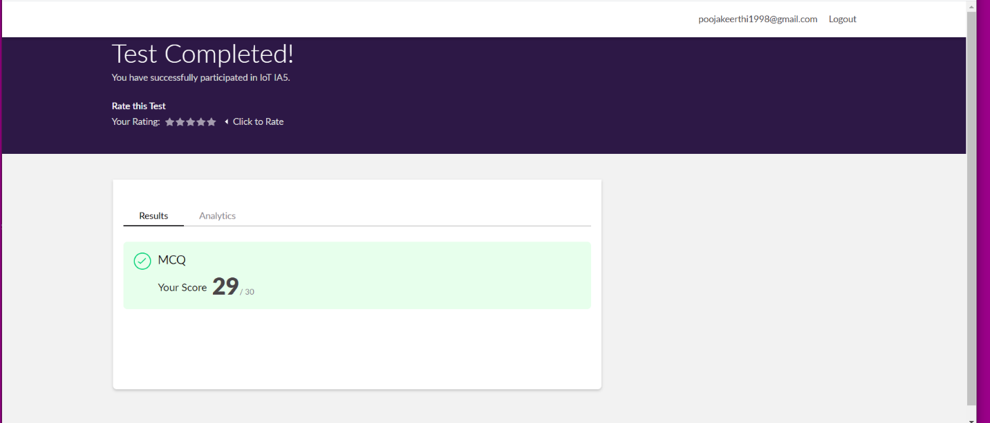

**Certification course**



Coding

|  |  |
| --- | --- |
|  |  |

**Program 2: Palindrome check Using Queue**

import java.util.Queue;

import java.util.Scanner;

import java.util.LinkedList;

class PalindromeTest {

public static void main(String[] args) {

System.out.print("Enter any string:");

Scanner in=new Scanner(System.in);

String inputString = in.nextLine();

Queue queue = new LinkedList();

for (int i = inputString.length()-1; i >=0; i--) {

queue.add(inputString.charAt(i));

}

String reverseString = "";

while (!queue.isEmpty()) {

reverseString = reverseString+queue.remove();

}

if (inputString.equals(reverseString))

System.out.println("The input String is a palindrome.");

else

System.out.println("The input String is not a palindrome.");

}

}

Output 1:

Enter any string:xyzzyx

xyzzyx

The input String is a palindrome.